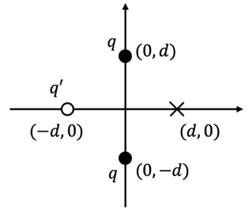
2025-2 General Physics II Midterm Exam Name: Student No.:
1. Three point charges are arranged as in Figure 1.
(a) [5 pts] If the net force on a test charge at $(d,0)$ is zero, determine $q'$.
(b) [5 pts] Calculate the potential energy of the system (without the test charge).

2. An electric dipole of moment $p=qd \hat{z}$ is formed by charges $±q$ separated by distance $d≪z$.
(a) [5 pts] Derive the electric field $E(z)$ along the dipole axis in $d≪z$ limit.
(b) [5 pts] Sketch electric field lines near the dipole, and plot the electric potential $V(z)$ along the dipole axis (no need for explicit formula).
Figure 1

3. Obtain the magnetic fields and sketch magnetic field lines for:
(a) [5 pts] an infinite straight line current $I$.
(b) [5 pts] a circular ring current $I$ of radius $R$; find the field at the center of the ring.
(c) [10 pts] An ideal solenoid with $n$ turns per unit length with current $I$. Find the magnetic field inside and outside the solenoid.

4. (a) [5 pts] Using Gauss’s law, derive the capacitance $C$ of an ideal parallel-plate capacitor with plate area $A$ and separation $d$. Assume vacuum between plates and neglect edge (fringing) effects.
(b) [10 pts] The capacitor is isolated and holds a fixed free charge $q$ on the plates. A dielectric with relative permittivity $κ$ completely fills the gap. How does the electric field between the plates change compared to the vacuum case, and why (in terms of polarization/bound charge)?
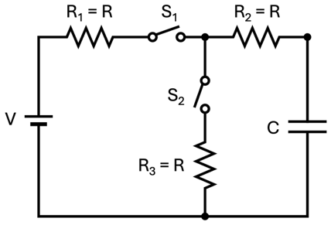
5. Consider a circuit shown in Figure 2. Initially, two switches $S_{1}$ and $S_{2}$ are open, and no charge is accumulated at the capacitor.
(a) [10 pts] First, $S_{1}$ is closed. Derive charge $q(t)$ at the capacitor.
(b) [10 pts] After the capacitor is fully charged, $S_{2}$ is closed. What are the currents flowing through $R_{1}$, $R_{2}$ and $R_{3}$, respectively?
(c) [5 pts] Now, $S_{1}$ is opened. Derive charge q(t) at the capacitor.
Figure 2
6. [20 pts] Consider a spherically symmetric electric field $\vec{E}\left(r\right)=E_{0}\frac{r}{r_{0}}\exp\left(-\frac{r^{2}}{r_{0}^{2}}\right)\hat{r}$. What is the charge density $ρ\left(r\right)$ that generates such electric field? (Hint: Take a spherical gaussian surface with radius $r$ and consider the enclosed charge is integration of charge density inside $r$: $q_{enc}=4π\int_{0}^{r}{{r^{'}}^{2}ρ(r')}dr'$.)

